**Lab 10**

**Task 1:**

**(i)** yes

**(ii)** yes

**(iii)** It still sounds like ‘we are you’

**Task 2:**

**(i) Number of Samples :** 38016 samples

**(ii) Sampling Rate :** 24000 Samples/second

(iii) **Bit resolution :** 16 bits/sample

(iv) **Time Duration :** 2376 seconds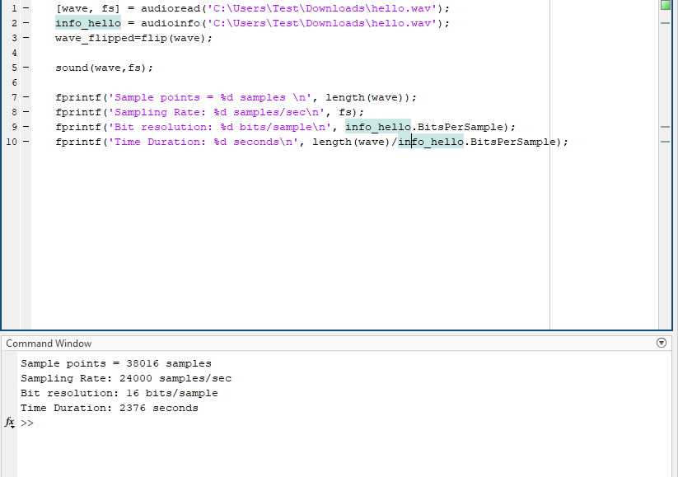

**Task 3:**



Code :

[wave, fs] = audioread('C:\Users\Test\Downloads\birthday.wav');

mul_wave_1 = -1*wave;

mul_wave_2 = 10*wave;

wave_sqrt1 = sign(wave) .* sqrt(abs(wave));

wave_sqr = wave.^2;

wave_flipped=flip(wave);

subplot(6, 1, 1);

plot((1:length(wave)) / fs, wave);

title('Original Audio Waveform');

xlabel('Time (seconds)');

ylabel('Amplitude');

subplot(6, 1, 2);

plot((1:length(mul_wave_1)) / fs, mul_wave_1);

title('Multiplied by -1 Audio Waveform');

xlabel('Time (seconds)');

ylabel('Amplitude');

subplot(6, 1, 3);

plot((1:length(mul_wave_2)) / fs, mul_wave_2);

title('Multiplied by 10 Audio Waveform');

xlabel('Time (seconds)');

ylabel('Amplitude');

subplot(6, 1, 4);

plot((1:length(wave_sqrt1)) / fs, wave_sqrt1);

title('Each sample replaced by its square root');

xlabel('Time (seconds)');

ylabel('Amplitude');

subplot(6, 1, 5);

plot((1:length(wave_sqr)) / fs, wave_sqr);

title('Squared Audio Waveform');

xlabel('Time (seconds)');

ylabel('Amplitude');

subplot(6, 1, 6);

plot((1:length(wave_flipped)) / fs, wave_flipped);

title('Flipped Audio Waveform');

xlabel('Time (seconds)');

ylabel('Amplitude');

sound(mul_wave);

**Task 4:**

Difficulty in listening the audio with 1KHz sampling rate

**Code:**

[wave, fs] = audioread('C:\Users\Test\Downloads\birthday.wav');

info_wave=audioinfo('C:\Users\Test\Downloads\birthday.wav');

% Load the original audio file

fs_1=4/3;

new_fs_1 = round(fs * fs_1); % New sample rate after decrease

wave_resampled_1 = resample(wave, new_fs_1, fs); % Resample the signal

fs_2=2/3;

new_fs_2 = round(fs * fs_2); % New sample rate after decrease

wave_resampled_2 = resample(wave, new_fs_2, fs); % Resample the signal

fs_3=1/3;

new_fs_3 = round(fs * fs_3); % New sample rate after decrease

wave_resampled_3 = resample(wave, new_fs_3, fs); % Resample the signal

fs_4=1/6;

new_fs_4 = round(fs * fs_4); % New sample rate after decrease

wave_resampled_4 = resample(wave, new_fs_4, fs); % Resample the signal

sound(wave_resampled_4,new_fs_4);

fs_5=1/12;

new_fs_5 = round(fs * fs_5); % New sample rate after decrease

wave_resampled_5 = resample(wave, new_fs_5, fs); % Resample the signal

fs_6=1/24;

new_fs_6 = round(fs * fs_6); % New sample rate after decrease

wave_resampled_6 = resample(wave, new_fs_6, fs); % Resample the signal

sound(wave,fs);

pause(2);

sound(wave_resampled_2,new_fs_2);

pause(2);

sound(wave_resampled_3,new_fs_3);

pause(2);

sound(wave_resampled_4,new_fs_4);

pause(2);

sound(wave_resampled_5,new_fs_5);

pause(2);

sound(wave_resampled_6,new_fs_6);

**Task 5:**



**Code:**

[wave, fs] = audioread('C:\Users\Test\Downloads\sunday.wav');

sound(wave,fs);

fs_1=147/320;

% Decrease the sample rate

new_fs = round(fs * fs_1); % New sample rate after decrease

wave_resampled = resample(wave, new_fs, fs); % Resample the signal

figure;

subplot(2, 1, 1);

plot((1:length(wave)) / fs, wave);

title('Original Audio Waveform');

xlabel('Time (seconds)');

ylabel('Amplitude');

subplot(2, 1, 2);

plot((1:length(wave_resampled)) / fs, wave_resampled);

title('Resampled Squared Audio Waveform');

xlabel('Time (seconds)');

ylabel('Amplitude');